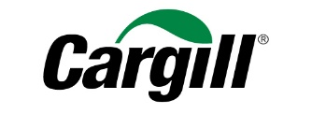

Brian Sikes
President, Cargill Protein

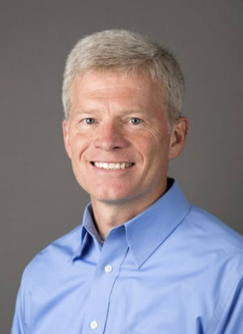
Currently the president of North American protein, Brian has recently been named the lead of Cargill’s Global Protein and Salt business. He will officially join the executive team in early 2019.

Brian began his career at Cargill in 1991. Most recently, he led the transformation of the North American protein business, which has delivered strong financial results and expanded offerings in line with shifting consumer demand for value-added protein, sustainable supply chains and alternative proteins. Brian also led the development of Cargill’s new North American Protein headquarters which officially opened in December 2018.

